BSCS/BSSE/BSDS/BSAI FINAL YEAR PROJECT PROPOSAL
Privacy-Preserving Healthcare GenAI

Term of Registration: Fall 2023



Particulars of the students:
Sr. # | Registration#  eg.L1F22BSCS0101 | Name in Full  Use Block Letters | Contact # | CGPA
1 | L1F23BSCS0192 | Faisal Khalid | 0317-4357289 | 2.34
2 | L1F23BSCS0199 | Syed Shah Wali | 0317-4357289 | 0.00
3 | L1F23BSCS0204 | M. Hammad | 0317-4357289 | 0.00
4 | L1F23BSCS0669 | Wajeeh ur Rehman | 0317-4357289 | 0.00

Project Type:
Software Development Artificial Intelligence (AI)

Faculty of Information Technology & Computer Science
University of Central Punjab
Privacy-Preserving Healthcare GenAI
Write down the brief project topic in four to five words only. However, the topic should not be ambiguous or very general.

Project Advisor
Sir Zulkifal
Acceptance of Project Idea
Students will be required to defend their idea before the scrutiny committee (SC) which has the authority to accept or reject the project idea. The decision taken by the SC will be final and cannot be challenged.
Similarly, in phase wise evaluations, the marks awarded by the evaluators will be considered final. No excuses on their skill, relevancy, competency or biasedness will be acceptable as an absolve.
Supervisory Meetings
A group is required to hold at least two meetings per month and maintain meeting minutes. Missing two consecutive meetings without any notice may lead to withdrawal of the project.
Advisor’s Consent
I Prof./Dr./Mr./Ms. ________________________________________________ am willing to guide these students in all phases of above-mentioned project as advisor. I have carefully seen the Title and description of the project and believe that it is of an appropriate difficulty level for the number of students named above.

Note:  Advisor can’t be changed and the duration for completion of the Project is 2 regular semesters (approx.) from the date of Registration of the Project. | Signatures and Date  Advisor

Student 1: Student 2: Student 3:
Name: Faisal Khalid Name: Shah Wali Name: Wajeeh ur Rehman
Registration# Registration# Registration#
L1F23BSCS0192 L1F23BSCS0199 L1F23BSCS0669
__________________ __________________ __________________
Signature Signature Signature

Student 4:
Name: M. Hammad
Registration#
L1F23BSCS0204
__________________
Signature

Table of Contents
Signatures and Date i
1. Abstract [max. 300 words] 1
1.1. Introduction of the Project [max. 200 words] 1
1.2. Problem Statement & Gap Analysis [max. 300 words] 1
1.3. Proposed Solution / Product Concept [max. 200 words] 1
1.4. Objectives & Target Market [max. 100 words] 1
1.5. Customer & User Research [max. 300 words] 2
• Target Customer Segment 2
• Industry Visit / Meeting with Target Customer 2
1.6. Tools and Technologies [max. 100 words] 2
• Frontend 2
• Backend 2
• Database 2
• Cloud 2
• Project Management 2
1.7. Expected Outcomes /KPI’s [max. 100 words] 2
• Product Outcomes 2
• Customer Outcomes 2
• Learning Outcomes 2
• Business Outcomes 2
2. Completeness Criteria [max. 200 words] 3
3. Challenges [max. 100 words] 3
4. Project Success Criteria [max. 100 words] 3
5. Related Work / Literature Survey / Literature Review [max. 500 words] 3
6. Project Plan / Project Schedule / Project Timetable / Project Calendar 3
7. References/Bibliography 3

Abstract [max. 300 words]
The Abstract must briefly summarize the following points in a separate page.
  - Begin your introduction by precisely defining the problem your FYP addresses. Explain it in a way that a reader unfamiliar with the topic can understand. Avoid any solution and focus only on problem.
  - Describe why this problem is significant. Discuss the practical, technical, or social implications of the problem and why it is worth solving in your project. Include your research on the market size, also mention how you calculated the market.
  - Explain why you chose this problem for your FYP and indicate the expected results.

Introduction of the Project [max. 200 words]
  - Provide a brief introduction of your project.
  - Explain the domain/context and any essential domain knowledge needed to understand the project work in a better way.
  - Highlight the significance of the problem, why this project is needed.
  - State your motivation behind choosing and pursuing this project, including factors like inspirations, personal experiences, industry collaboration or your own relevant background.

Problem Statement & Gap Analysis [max. 300 words]
Describe the exact problem your project trying to solve while considering the following points:
  - Explain the real-world environment/ situation in which the problem exists relevant to your FYP problem.
  - Identify the main problem or inefficiency by showing existing solutions and competitor analysis. Also, highlight what’s different about your approach.
  - Explain what important need is not being fulfilled or what opportunity your project aims to capture.

Proposed Solution / Product Concept [max. 200 words]
  - Describe your FYP product or service along with its purpose and how it provides value to users.
  - Explain how your solution solves key user problems and the benefits it delivers.
  - List the main features of your product and prioritize them based on their value to users.
  - Describe the measurable positive changes or improvements your solution is expected to create.

Objectives & Target Market [max. 100 words]
  - Clearly state what your project will achieve in the end.
  - Write all objectives very clear and easy to understand.
  - Ensure your project scope is explicit and should be completed on time.
  - Explain how your project will add value or facilitate people.

Customer & User Research [max. 300 words]
  - Target Customer Segment: Explain who are the main users or customers of your project and how they will become successful beneficiaries.
  - Industry Visit / Meeting with Target Customer: Visit any organization related to your FYP and note observations that help identify actual problems or user needs for your project. Mention User Research you have conducted including the findings of that research conducted with an organization or consumers.
  - Also, mention these points explicitly in your proposal. This is very important in refining problem statements of your FYP project.

Tools and Technologies [max. 100 words]
  - Frontend: Mention list of frontend development tools you are using for the user interface (e.g., React, Flutter).
  - Backend: Describe what server-side technologies you will use (e.g., Node.js, Django).
  - Database: List the databases technologies you will use (e.g., MySQL, MongoDB).
  - Cloud: Mention cloud platforms or services if you are using (e.g., AWS, Azure).
  - Project Management: List down tools for planning and tracking (e.g., Jira, Trello).

Expected Outcomes /KPI’s [max. 100 words]
  - Product Outcomes: Define success of your project. Describe what final product/service outcomes your project will deliver.
  - Customer Outcomes: Explain the benefits or improvements users will experience when using your product/service. Define KPIs you are looking to achieve, this includes but not limited to number of users who will try this product, any retention numbers.
  - Define how you will measure this KPI.
  - Learning Outcomes: You need to highlight what skillset, knowledge, and insights gained during the project development process.
  - Business Outcomes: Describe measurable impacts on the business when deployed such as efficiency, revenue and user comforts.

Completeness Criteria [max. 200 words]
  - Define project completeness criteria in terms projects milestone along with the submission breakup into sub milestones. Clearly highlight in sub milestones when you are going to learn from usage data to make improvements in your work.

S.No | Criteria | Measurable Outcome / Success Indicator | Weightage (%)
1 | Kubernetes Operator Implementation | kopf-based FLCluster CRD is created, updated, and deleted cleanly. Operator reconciliation loop runs without crashing on a live K3s cluster. FLCluster resource status reflects real-time round state. | 20%
2 | FL Training Round Execution | A complete federated training round (model broadcast → local training → update collection → aggregation → round counter increment) executes end-to-end across a minimum of 4 client nodes without manual intervention. | 20%
3 | Secure Aggregation (PySyft SMPC) | Individual client model updates are aggregated using Secure Multiparty Computation. No single client update is recoverable from the aggregated result. Verified by inspection of intermediate data at the aggregation server. | 15%
4 | Fault Tolerance & Recovery | System detects a simulated client pod failure mid-round, reschedules or proceeds with remaining quorum, and completes the training round. Recovery time is logged and is within 60 seconds of failure onset. | 15%
5 | Kubeflow Pipeline Integration | FL training lifecycle is defined as a reproducible Kubeflow DAG pipeline. Pipeline executes minimum 10 rounds. All round results, metrics, and model versions appear in MLflow experiment tracking dashboard. | 10%
6 | Benchmarking & KPI Verification | Federated model achieves ≥85% of centralized model accuracy on IoT anomaly detection benchmark. Communication overhead per round is measured and documented. All 4 KPIs from Section 8 are met and independently verifiable. | 10%
7 | Deployment Guide & Reproducibility | A third party can deploy the complete FL-KubeOps system on any K3s cluster by following the published GitHub guide without team assistance. Deployment guide is tested by at least one team member not involved in writing it. | 10%
 | TOTAL | All criteria independently verifiable by FYP evaluation committee | 100%

Challenges [max. 100 words]
  - Discuss how you manage time for FYP tasks within the given timeline.
  - List down pointwise how you will improve your technical skills for applying existing/emerging tools or technologies in your project.
  - Discuss how you will stay motivated, consistent and focused till the final stage of your FYP deliverables.

Project Success Criteria [max. 100 words]
  - Clearly describe the nature of the final result of your FYP. Specify whether it will be an application, software service, research tool, simulator, or any other tangible outcome.

Related Work / Literature Survey / Literature Review [max. 500 words]
  - If your project is research-oriented, you should provide literature review summarizing existing research or solutions in your FYP research area. Highlight what has been done so far, e.g.; research gaps, and how your project builds on or differs from previous work.

Feature | FL-KubeOps (This Project) | Flower (Beutel et al., 2020) | OpenFL (Intel, 2021) | Kubeflow (Vanilla / Stock) | Manual FL Deployment
Kubernetes-Native Operator (CRD) | ✔ Yes — FLCluster CRD managed by kopf controller | ✗ No — runs on K8s but not as an operator | ✗ No — no CRD abstraction | ~ Partial — TFJob/PyTorchJob only; no FL round concept | ✗ No — manual pod management required
FL Round Orchestration | ✔ Yes — automated fan-out, quorum wait, aggregation, advance | ✔ Yes — built-in strategy engine | ✔ Yes — plan-based workflow | ✗ No — no round concept | ✗ No — fully manual per round
Secure Aggregation (SMPC) | ✔ Yes — PySyft SMPC; server cannot recover individual updates | ~ Partial — SecAgg available in experimental branch | ✔ Yes — TLS + SMPC support | ✗ No — no FL privacy primitives | ✗ No — depends entirely on implementer
Automatic Failure Recovery | ✔ Yes — operator detects pod failure, reschedules within 60s | ✗ No — client dropout is caller's responsibility | ~ Partial — limited retry logic | ✗ No — standard K8s pod restart only | ✗ No — no recovery mechanism
MLflow Experiment Tracking | ✔ Yes — every round versioned; metrics in MLflow dashboard | ✗ No — no built-in experiment tracking | ✗ No — no MLflow integration | ✔ Yes — native MLflow + KFP integration | ✗ No
Declarative Configuration (YAML/CRD) | ✔ Yes — single FLCluster manifest deploys full FL cluster | ✗ No — Python API only | ✗ No — JSON plan files | ✔ Yes — pipeline YAML definitions | ✗ No — imperative scripts only
Edge / Local Hardware Support | ✔ Yes — runs on K3s on commodity laptops | ✔ Yes — any Python environment | ~ Partial — enterprise-focused; cloud preferred | ~ Partial — requires full K8s; resource heavy | ✔ Yes — hardware agnostic
Kubeflow Pipeline Integration | ✔ Yes — FL round DAG in Kubeflow Pipelines | ✗ No | ✗ No | ✔ Yes — native | ✗ No
Python-Native Implementation | ✔ Yes — 100% Python stack — kopf, PySyft, KFP SDK | ✔ Yes — Python | ~ Partial — Python client; some Go infrastructure | ~ Partial — Python SDK; Go core | ✔ Yes — typically Python
Open Source & Reproducible | ✔ Yes — MIT license; full GitHub reproducibility guide | ✔ Yes — Apache 2.0 | ✔ Yes — Apache 2.0 | ✔ Yes — Apache 2.0 | ✗ No — typically internal scripts
Designed for FL as a First-Class Workload | ✔ Yes — core design principle; FL = native K8s resource | ~ Partial — FL-first algorithm design; infra is secondary | ~ Partial — enterprise FL-first; K8s is deployment environment | ✗ No — general ML platform; FL is an afterthought | ✗ No — no design principle; ad-hoc

Project Plan / Project Schedule / Project Timetable / Project Calendar
  - Concrete description of what you plan to do. Your plan must include clear milestones for every week until the project due date. After development of the WBS, schedule the subtasks/activities in a way that the work is completed in time. Show the schedule as GANTT chart. Describe the use of resources for each subtask. Indicate how you and your advisor will be monitoring the progress on periodic-basis.
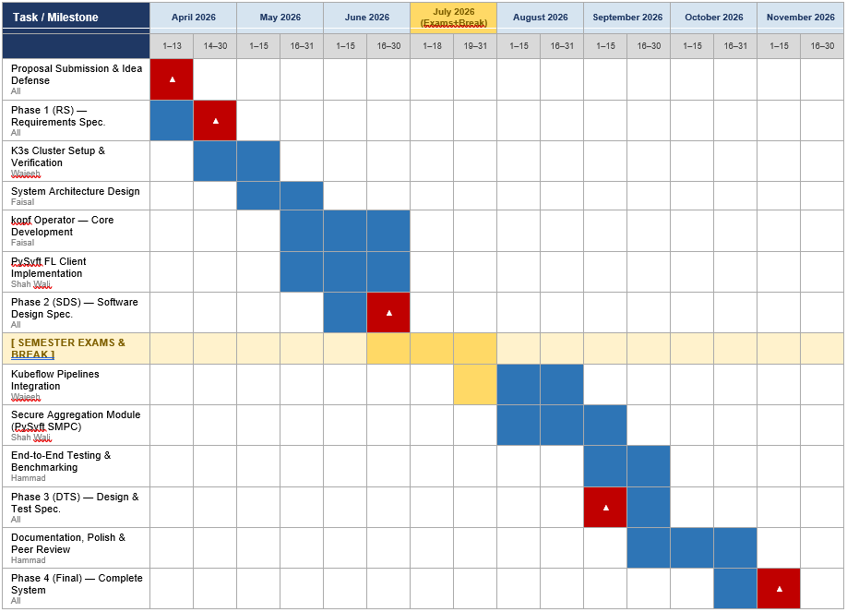
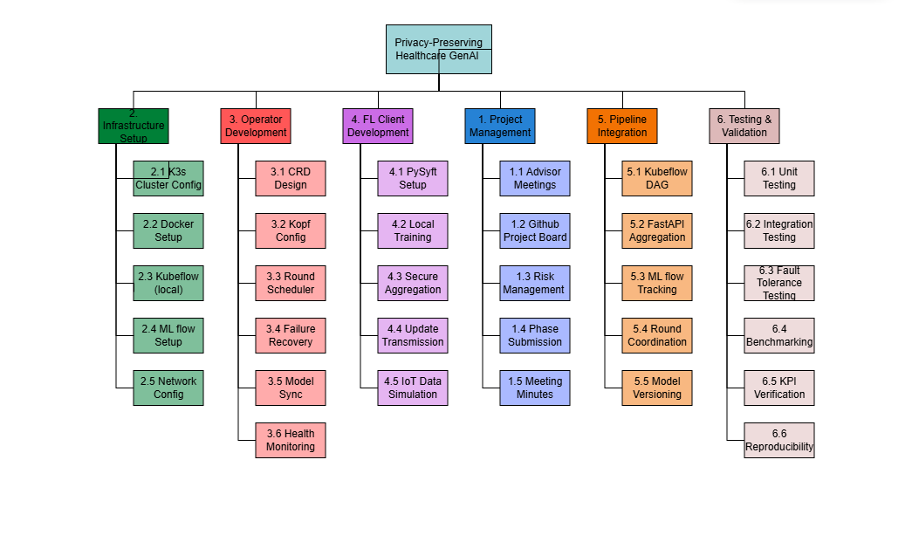

References/Bibliography
Please give references to the resources you have consulted in finalizing your project topic.

